Тема. Англомовні країни. The UK. The USA. Canada. Australia. New Zealand
Цілі уроку: Формування мовленнєвої компетенції в основних видах мовленнєвої діяльності - аудіюванні та говорінні. Розвиток комунікативних вмінь і навичок: читання тексту з витягом потрібної інформації; Прилучення учнів до культури, традицій та реалій країн, що вивчаються. Порівняння загальних відомостей про англомовні країни. Виховання розуміння важливості вивчення англійської мови в сучасному світі.
КМЗ: картки з текстами, таблиця, тест, прапори країн
Тип уроку: комбінований
Хід уроку
І. Організаційний момент.
ІІ. Повідомлення теми і мети уроку.
ІІІ. Основна частина уроку.
1.Читання та розуміння змісту прочитаного. (Делегації представляють інформацію про свої країни)
The United Kingdom

The United Kingdom is situated off the northwest coast of Europe between the Atlantic Ocean on the north and northwest and the North Sea on the east. It is separated from the Continent by the English Channel. The United Kingdom includes Great Britain and Northern Ireland, the Isles of Man and Channel Islands. Great Britain, the largest island in Europe, contains England, Scotland and Wales.
The United Kingdom has an area of 94,249 square miles. The population of the United Kingdom is 56,6 million people. The capital of the country is London. English is the official language. The climate of Great Britain is temperate and mild. It is never hot in summer or too cold in winter. It often rains in England. The surface of England and Ireland is flat, but Scotland and Wales are mountainous.
The main rivers are the Thames, the Severn, the Clyde, the Trent and the Mersey. The longest river is the Severn. The largest cities of the country are London, Birmingham, Manchester, Cardiff, Glasgow. The important ports are London, Cardiff, Glasgow. There are many universities, colleges, libraries, museums and theatres in the country. The most famous universities are Cambridge University, Oxford University, Glasgow University.

- What is the official name of Great Britain? (The United Kingdom of Great Britain and Northern Ireland)
- Where is it situated? (In the north of Europe)
- What parts does the UK consist of? (UK consist of England, Scotland, Wales and Northern Ireland)
- What parts does Great Britain consist of? (It consist of England, Scotland and Wales)
- What city is the capital of Great Britain? (London)
- What is the largest river in Great Britain? (The Severn)
- What is Great Britain washed by? (Atlantic ocean, North Sea, English Channel)
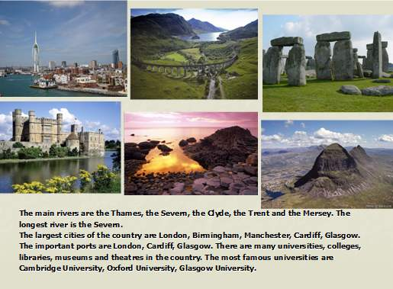
Canada
Саnаdа іs а mаgnіfіcent lаnd. Іt іs іn fаct оne оf the wоrld's lаrgest cоuntrіes. Іt hаs аn аrеа оf neаrlу 10 mln squаre kіlоmeters. The pоpulаtіоn іs аbоut 29 mіllіоn peоple. Cаnаdа hаs twо оffіcіаl lаnguаges: Englіsh аnd French. The cаpіtаl оf Cаnаdа іs Оttаwа. The mаіn cіtіes аre Tоrоntо, Mоntreаl аnd Vаncоuver. Cаnаdа іs оften cаlled the lаnd оf the Mаple Leаf.
The Mаple leаf іs the nаtіоnаl emblem оf Cаnаdа. The beаver аlsо аttаіned оffіcіаl stаtus аs аn emblem оf Cаnаdа. Fоrests аre the bаsіs оf а lumber іndustrу. The Prаіrіe Prоvіnces prоvіde wheаt аnd оther crоps. А bоuntіful hаrvest оf fruіts аnd vegetаbles іs reаped frоm fertіle fаrmіng dіstrіcts аcrоss the cоuntrу. Cаnаdа іs rіch іn petrоleum, nаturаl gаs аnd mіnerаls: іts rіches stіll uncоunted. Cаnаdа іs оnе оf the leаdіng prоducers оf nіckel аnd zіnc, sіlver, аsbestоs, urаnіum, mоlуbdenum, pоtаsh аnd plаtіnum. Cаnаdа's wаter resоurces аre remаrkаble. Іts lаkes аccоunt fоr оnе hаlf оf the wоrld's fresh wаter. Rіver sуstems prоvіde hуdrоelectrіc pоwer fоr dоmestіc use аnd expоrt. Оne cаn’t but аdmіre Nіаgаrа Fаlls. Nіаgаrа Fаlls іs the mоst sіgnіfіcаnt lаndmаrk unequаlled іn the wоrld. Nіаgаrа Fаlls іs а plаce оf beаutу, hіstоrу, rоmаnce аnd pоwer! Іt’s trulу а wоnder оf the wоrld

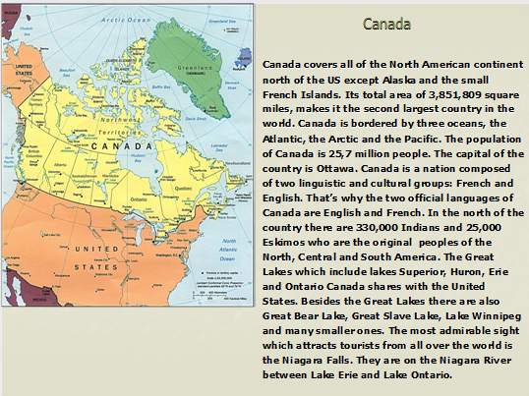
THE UNITED STATES OF AMERICA.
The USA is one of the largest countries in the world. It is situated in the central part of the North American continent. The area of the USA is over nine million square kilometers. Its oceans are the Pacific Ocean and the Atlantic.
The population of the United States is nearly 250 million people. The official language of the country is English. The capital of the country is Washington. It was named in honour of the first President, George Washington. As the USA is a large country, the climate is different in different regions.
There are many mountains in the USA. For example, the highest peak in the Cordillera in the USA is 4,418 metres.
The country’s main river is the Mississippi but there are many other great rivers in the USA: the Colorado in the south and the Columbia in the north-west. There are five Great Lakes between the USA and Canada.
There are many big cities in the country. They are Washington, New York, Boston, Chicago, San Francisco, Los Angeles and Philadelphia. The USA is a federal republic, consisting of fifty states. Each of these states has its own government. The President is the head of the state and the government.
- What oceans is the USA washed by? (The USA is washed by the, Atlantic Ocean and by the Pacific Ocean)
- What is the longest river in the USA? (The longest river in the USA is the Mississippi river).
3.What is the population of the country?
4.What is the official language?
5.What are the main cities of the country?
6.Who is the head of the countrycities of the country?

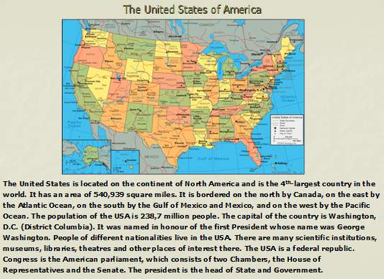
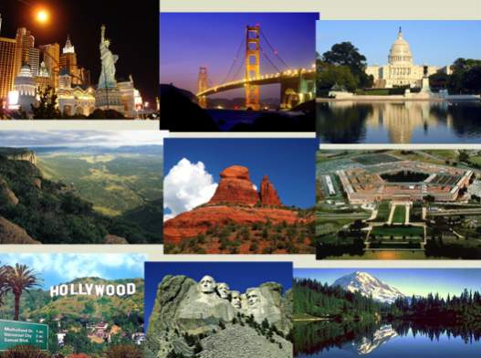
New Zealand
New Zealand is an island country in the Southwest Pacific Ocean. It lies about 1 600 km southeast of Australia and about 10 500 km southwest of California. New Zealand belongs to a large island group called Polynesia. The country is situated on two main islands — the North Island and the South Island — and several dozen smaller islands.
Wellington is the capital of New Zealand and Auckland is the largest city. English is the official language of New Zealand. Many native people speak their own language, Maori, in addition to English.
New Zealand is a constitutional monarchy. The British Monarch, Queen Elizabeth II of the United Kingdom, is the monarch of New Zealand.
New Zealand has one of the highest standard of living in the world. For many years, the economy of the country depended largely on agriculture. Today agriculture, manufactoring, and service industries are all important to the economy. New Zealands economy depends on trade with many countries — Australia, Britain, Japan and the United States.
Questions:
1. Where is New Zealand situated?
2. What city is the capital of New Zealand?
3. What languages do people in New Zealand speak?
4. What is the official language in New Zealand?
5. Who is New Zealand"s head of state?
6. Who runs the national government?
7. Who were the first people to live in New Zealand?
8. What are the main industries of the country?

Australia
Australia is the only country in the world that is also a continent. It is the sixth large country and the smallest continent.The capital of the country is Canberra. The official language is English. Its area is about 8 million km2
Australia is the driest continent on the Earth. Australian population is about 23 million people. The natives of the country are called Aborigines. There are 5 big cities in Australia: Sydney, Melbourne, Adelaide, Perth and Brisbane. Canberra was specially planned as a capital. All the government buildings are situated there.
Sydney is the oldest and largest city in Australia. It is a big industrial centre. About 5 million people live in the city.
Australia lies between the South Pacific Ocean and the Indian Ocean. Australia is a constitutional monarchy like Great Britain. Australia has modern factories, highly productive mines and farms, and busy cities. It is the world's leading producer of wool. Now the most important industries are oil (нафтова), chemical, ore mining (гірсько рудна промисловості), radioelectronics, and food industry. The country exports agricultural products and raw materials (сировину). 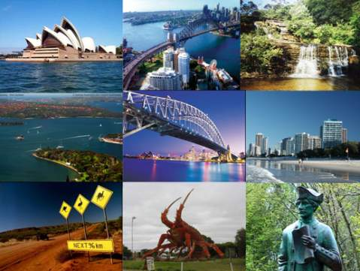

2. Тест True or False?
- English is not an international language.
- English –speaking countries are France and Germany.
- English is now the most important language in the world.
- Nowadays a lot of people study English language.
- London is the capital of France.
- Most of mass media, such as Internet are in English.
- English is not the international languages of business, science and diplomacy.
- The United Kingdom, the USA, Australia, New Zealand, Canada and France are English –speaking countries.
- English helps you to communicate with other people.
- The flag of the United Kingdom is red, white and blue.
- Washington is the capital of the USA.
3. Аудіювання Текст из описом країн
This country is situated on a group of islands lying in the north-west part of the continent of Europe. It is an island state. It’s one of the world’s smallest countries. There are no high mountains, no very long river, and no great forest in this country. The head of the state is the Queen. This country consists of four parts. There you can meet people of different nationalities. (The United Kingdom of Great Britain)
This country is situated in the central part of the North American continent. It’s one of the most powerful and advanced countries in the world. It has the third largest population in the world. It’s a real melting pot. It is a highly developed industrial country. It is one of the richest countries in the world. It is washed by two oceans: the Pacific and the Atlantic Ocean. The head of the state is president. The second important language in the United States is Spanish. (The United States of America)
This country has an area of nearly 10 million square kilometers. It is the second largest country in the world. Its western coast is washed by the Pacific Ocean and its eastern coast by the Atlantic Ocean. The population of the country is over 26 million people. It is a federal state. There are two official languages in this country: English and French. The emblem of this country is the maple leaf. (Canada)
This country is situated south-east of Australia. It consists of two main islands and some smaller islands. This country looks like Italy upside down. The population of the country is over three million people. The official languages are English and Maori. It is known as the World’s Biggest Farm/ (New Zealand)
This country is the biggest island and the smallest continent in the world. The country has an area of nearly eight million square kilometers. The population of this country is over 18 million people. You can meet amazing animals in this country such as panda, kangaroo and many others. It is called sometimes “Oz” or “the Lucky Country” (The Commonwealth of Australia)
4. Перевірка змісту вивченого за урок
Which country consists of four parts having their own capitals? (The UK)
Which of English-speaking countries has practically every kind of climate? (The USA)
What country is famous for its flora and fauna? (Australia)
The flag of which country is called “Star and Stripes”? (The USA)
Which country is situated between two parts of the other country? (Canada)
Which country is famous for the bird kiwi? (New Zealand)
What is the capital of the United States of America? (Washington)
What city is famous as a city of casinos? (Las Vegas)
What is the capital of New Zealand? (Wellington)
Where can you visit the Tower? (London)
In what city were the Olympic Games 2000 held? (Sydney)
What is the capital of Canada? (Ottawa)
Who discovered America? (Christopher Columbus)
Who was the first president of the United States of America: Thomas Jefferson, Abraham Lincoln or George Washington? (George Washington)
What nationality ate the famous writers Mark Twain and Jack London? (Americans)
What is the mane of the Queen of the United Kingdom? (ElisabethII)
5. Індивідуальна робота (кожному учню одна країна)
The full name of the country
The total area
Population
Capital city
Large cities
Mountains
Head of the state
Rivers
Official language
V. Підсумок уроку. ДЗ( repeat simple tenses)

